**Dynamic UI Framework**

Contents:

1. Introduction

1.1 About This Document

1.1.1 Scope of this document

1. Component Design

2.1 Component design diagram

2.1.1 Overall Workflow

2.1.2 Low Level Design

1. Technology & Frameworks Used
2. Solution Approach

1. Introduction

1.1 About this document

1.1.1 Scope & Purpose of this document

A Dynamic UI is a user interface that can adapt according to user input. A framework is the basic structure underlying a system. This Dynamic UI Framework will focus on creating a hassle-free interface for the user and will store most of the html data in a JSON format in the client machine in order to reduce time and ultimately, improve user experience. The purpose of this document is to provide a blueprint for developers who want to create a reusable component for a user interface that can be integrated into any application of the same tech stack.

2. Component Design

Component Design Diagram

Advanced Search

Logger

Generic UI

This is an implementation of a sample template featuring a Dynamic UI where the client will interact with the UI while being able to change/view information available by making use of their configuration file.

2.1.1 Overall Workflow

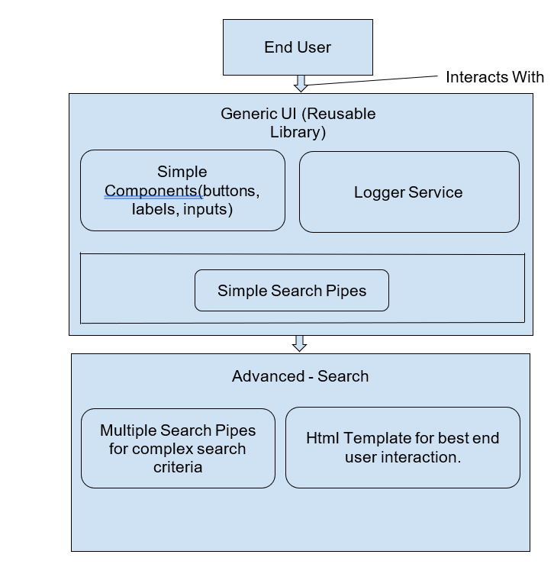

2.1.2 Low level Design

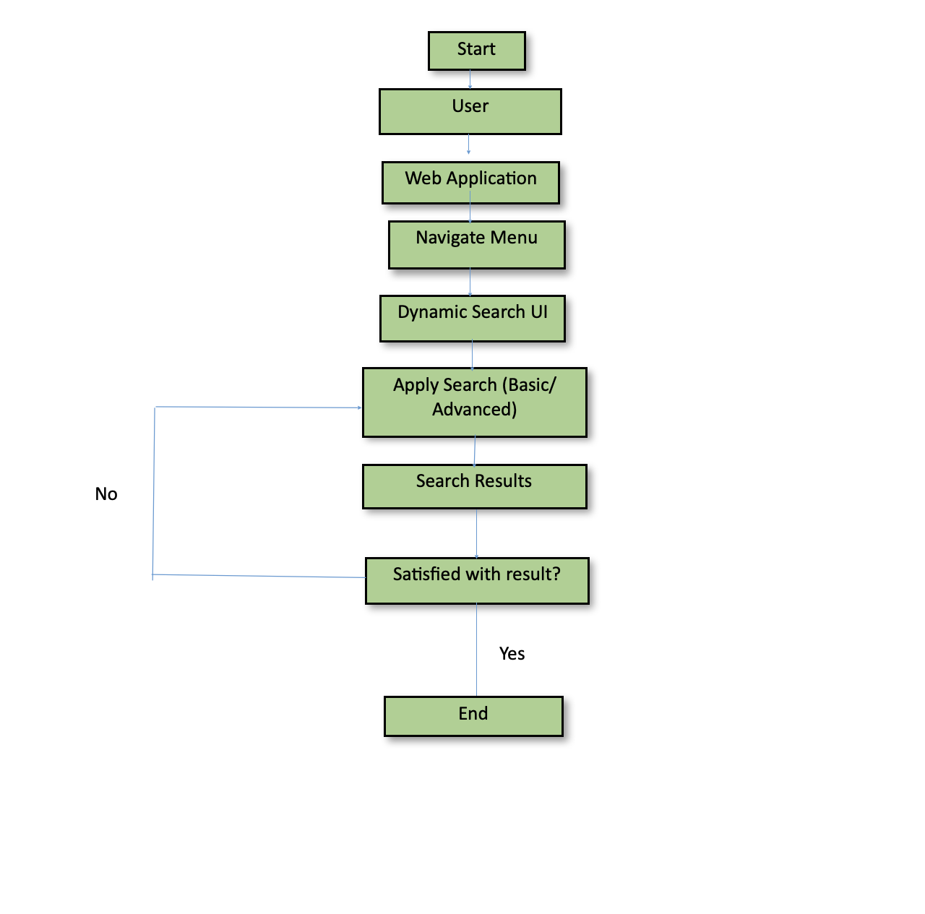

3 Technology & Frameworks used  
This below lists down the details on technology and framework used for development of the UI.

* 1. Angular 15.2.4
  2. Node 19.7.0
  3. AG-Grid-Angular

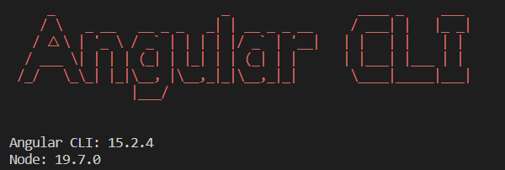

4 Solution Approach

This is a description of how we see clients using our framework.

We have multiple methods that can be reused for many Use-Cases.

These include:

* Generic UI (dynaui-fragmenT)
* Logger
* Simple/ Advanced Search

AG-Grid is a powerful data grid library for Angular. It provides a feature-rich solution for building interactive data-centric applications. You can bind the grid to various data sources like arrays, objects, or APIs. It supports sorting, filtering, and pagination for efficient data manipulation. AG-Grid offers row selection, editing, and inline cell editing capabilities. You can group and aggregate data based on columns for easy analysis. Customization options allow you to modify the grid's appearance and behavior. It adheres to accessibility standards and supports internationalization. AG-Grid offers advanced features like tree data structures and Excel-like filtering. Integration with UI frameworks like Bootstrap and Material Design is possible. It has comprehensive documentation and a flexible API for easy implementation. The library is constantly evolving with updates and new features. AG-Grid enhances performance with virtual scrolling and optimized rendering. It supports exporting data to various formats like CSV and Excel. AG-Grid is highly flexible and can be seamlessly integrated into Angular applications.